DRIVER
FIRST NAME
FAMILY NAME
NATIONALITY  (COUNTRY) |  |  | Choose your country |  |  |  |  |  |  | ASN | Choose your ASN
INTERNATIONAL LICENCE |  |  | GRADE: |  | Grade |  |  | LICENCE N°:
DATE OF BIRTH [DD/MM/YYYY] |  |  |  |  |  | / /
ADDRESS |  |  |  |  |  |  |  |  |  | MOBILE |  |  | ++
 |  |  |  |  |  |  |  |  |  | PHONE |  |  | ++
 |  |  |  |  |  |  |  |  |  | EMAIL
COMPETITOR - IF IDENTICAL TO THE DRIVER, TICK THE BOX
COMPETITOR - to be completed if someone other than the driver
NAME
ASN |  |  | Choose your ASN
INTERNATIONAL LICENCE N°
ADDRESS |  |  |  |  |  |  |  |  |  | MOBILE |  |  |  | ++
 |  |  |  |  |  |  |  |  |  | EMAIL
CAR
MAKE |  |  |  |  |  |  |  | MODEL  (EXACT TYPE)
MAKE OF THE ENGINE
CYLINDER CAPACITY |  |  |  | cm³ |  |  |  | TURBO or SUPERCHARGER: YES NO
TECHNICAL  PASSPORT N° |  |  |  |  |  |  |  | HOMOLOGATION N°  (if applicable)
FUEL |  | PETROL |  |  |  |  | DIESEL |  | ALTERNATIVE ENERGY  Specify:

SAFETY EQUIPMENT - Conformity of the Driver’s safety equipment
► For cars of the FIA Groups: safety equipment must comply with Appendix J.
► For cars of non-FIA Groups of Category 3 and Category 4: safety equipment must comply with the national regulations of theirASN. The safety harness must be homologated by the FIA. For GTand Touring Cars, the rollbar is mandatory and homologated by the FIA or certified by an ASN.
► The wearing of a safety belt, a crash helmet, a head restraint device and flame-resistant clothing (including the overall, a mask or balaclava, gloves, etc.) complying with the standards approved by the FIA (or for Competitors in Category 3 and Category 4,
complying with the standards for Driver safety equipment approved by their ASN) is mandatory during the practice and race heats.

MASTERS COMPETITION
ELIGIBILITY
Choose your criterion (criteria) for admission
Among the first 12 in the FIA European Hill Climb Championship (in Category 1 or 2)
Among the first 12 in the FIA International Hill Climb Cup (in Category 1, 2 or 3)
Among the first 3 in an FIA Zone Championship
Among the first 5 in a category of the National championship / (UK: Among the first 10 in the final overall classification MSA BHCC)
Among the first 3 in a group of the National championship / (UK: Among the first 3 in the Road., Mod., Sports or Racing categories)
Driver aged less than 25 years (born after 14 October 1993) – appointed by the ASN
Female Driver – appointed by the ASN
Wild Card (request to be submitted in advance to the FIA Hill Climb Commission – see “WILD CARD” form)
► “MASTERS” CATEGORISATION
Choose your category and your group

 | CATEGORY 1 – “PRODUCTION” / FIA | ► | Group (FIA) Choose your FIA Group
 | CATEGORY 2 – “COMPETITION” / FIA | ► | Group (FIA) Choose your FIA Group
 | CATEGORY 3 – “OPEN – PRODUCTION”  ► E1 (FIA)  ► E1 (non-FIA) or Touring or GT (non-FIA) | ► | Group E1 (FIA)  Group NATIONAL (non-FIA)  Specify your national GROUP:
 | CATEGORY 4 – “OPEN – COMPETITION”  ► Single-Seater or Sportscar (non-FIA) | ► | Group NATIONAL  Specify your national GROUP:

“MEDIA” FORM / DRIVER INFORMATION
NAME |  |  |  |  |  |  |  |  |  |  |  |  |  |  |  |  | AGE
COUNTRY |  |  |  |  |  |  |  |  |  |  |  |  | BIRTH PLACE  [& rEgion] | [ ]
PROFESSION |  |  |  |  |  |  |  |  |  |  |  |  | MARITAL STATUS
DETAILS OF 1ST MOTOR  SPORT COMPETITION |  |  | Year: |  |  |  |  |  | Discipline: |  |  |  |  |  | Race:
DETAILS OF 1ST HILL CLIMB |  |  |  |  |  | Year: |  |  |  | Race:
CARS DRIVEN DURING CAREER
BEST rEsult(s) In 2018
BEST RESULT (CAREER)
Record(s)?
Hobbies
ProjeCts

ORGANISATION OF THE PADDOCK
NAME OF THE COMPETITOR |  |  | NAME OF  THE DRIVER
TEAM MEMBERS - NUMBER
► CONTACT PERSON
(PADDOCK)
► MOBILE | ++
Is another DRIVER/CAR part  of this same structure? ► |  | If yes, indicate the name of the 2nd driver
 |  | If yes, indicate the name of the 3nd driver

Choose your paddock layout and specify dimensions

 | 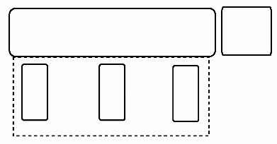 | Length x Width [m]  x |  | 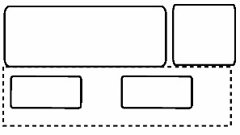 | Length x Width [m]  x
 | 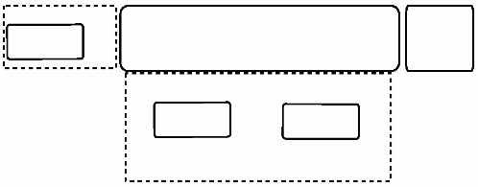 | Length x Width [m]  x |  | 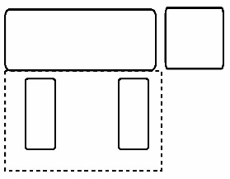 | Length x Width [m]  x
 |  | Length x Width [m]  x |  |  | Length x Width [m]  x
 |  | Length x Width [m]  x |  | OTHER?  Please send details to the  Organisers. | Length x Width [m]  x
----- = tent

Please specify

 | Quantity | Make & Model
CAR
TRAILER
VAN
CAMPER
TRUCK

COMMON DECLARATION | We accept the Common Declaration

- We confirm that we have read and understood the provisions of the International Sporting Code and the applicable Sporting and Technical Regulations, and we agree, on our own behalf and on behalf of everyone associated with our participation in the 2018 FIA Hill Climb Masters, to observe and be bound by them (as supplemented or amended). We declare that we have examined this Entry Form and that the information given is true, correct and complete. We understand that any change to the details given on this Entry Form must be notified to the organisers and to the FIA, at the latest on the official closing date for entries, so that the organisers and the FIA may reappraise our entry.  - We understand that failure to notify the FIA of any changes made to the details supplied on this form may result in our exclusion from the FIA Hill Climb Masters.  - We understand that only entries made no later than the closing dates and times set by the FIA may be studied and then taken into consideration for the selection of the participants. We understand that, in order to be valid, the entry must be completed by all the documents required.  - We understand that any documents (copy of the Competitor’s licence, etc.) which are not appended to the entry must be sent to the organisers and to the FIA (by email) before the given date. | - We understand that any entries sent after this date will be considered null and void. The time of sending shown on the electronic communication will be used as conclusive evidence. We understand that any entries sent by fax will be refused and considered null and void.  - We understand that it is up to each Competitor to ensure that the information given on the entry form is correct. The FIA accepts no responsibility in the event of false or incorrect information.  - We understand that the Driver must attend, if requested and invited to by the FIA, autograph sessions and any press conference and/or media sessions organised during the Competition.  - We understand that our entry cannot be considered as definitive until the organisers or the FIA have informed us of its validation.
IX. PERSONAL DATA POLICY
By accepting the Common Declaration, we acknowledge that we have read, understood and accepted the Personal Data Policy without limitation or reservation.

OBLIGATORY DOCUMENTS TO BE SENT TO THE ORGANISATION - BY EMAIL
+ 1 ENTRY FORM COMPLETED, DATED AND SIGNED.
+ 1 COPY OF THE INTERNATIONAL DRIVER’S LICENCE.
+ 1 COPY OF THE INTERNATIONAL COMPETITOR’S LICENCE.
+ 1 COPY OF THE CAR DRIVING LICENCE.
+ 4 PHOTOS, AT LEAST ► HIGH RESOLUTION AND copyright free (MIN. 1000 KO / FORMAT JPG).
► MIN. 2 PORTRAIT PHOTOS OF THE DRIVER IN OVERALLS.
► MIN. 2 PHOTOS - VEHICLE IN ACTION.

ENTRY FEE
NO ENTRY FEE - DROIT D’ENGAGEMENT GRATUIT - KEIN NENNGEBÜHR - ISCRIZIONE GRATUITA - ŽÁDNÝ VKLAD

SIGNATURE – COMPETITOR | SIGNATURE – DRIVER
DATE : / / | DATE : / /
The signature can be electronic or handwritten.
*If signature is electronic: please insert the image (scan) of your signature in the appropriate field(s).
*If signature is handwritten: please print the last page of the form, sign it and send the scan of this last page by email.

